**SPECTROPHOTOMETER**

The project entitled “A Low-Cost Spectrophotometer” was undertaken at Design Innovation Centre, UIET, Panjab University and was sponsored by MHRD.

This project focused on developing a low-cost replacement for a spectrophotometer. A spectrophotometer is an instrument that helps in studying how light interacts with matter, by analysing the measurements and reactions of wavelength of light and its radiation intensity. It cannot be called a unique or specialized field but it is an integral component of the scientific processes under a variety of disciplines like physics, chemistry, material and chemical engineering, biochemistry, and clinical applications. The cost of an actual spectrophotometer falls in the range of Rs. 2 Lakhs and above. The wide range of applications that the spectrophotometer can be put to use undergirds the necessity of development of this project. The prime targets for the for the product initially include high-schools and colleges.

The prototype fabricated during the project period is capable of performing the basic

experiments with the accuracy equivalent to a high-end spectrophotometer. In addition to

schools and colleges, it can be calibrated specifically to perform experiments in laboratories.

The hardware used in the prototype is readily available in the market if required for

replacement. The software being used are opensource.

Fig. 1 Designed Prototype.

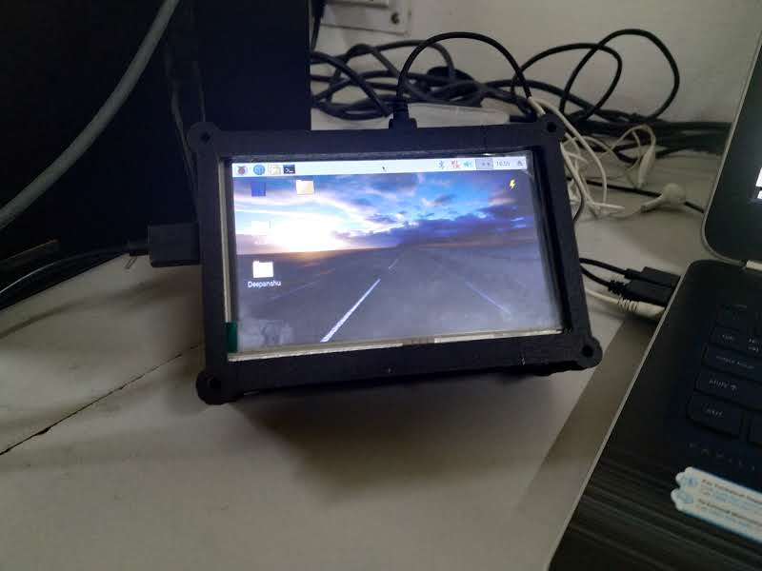

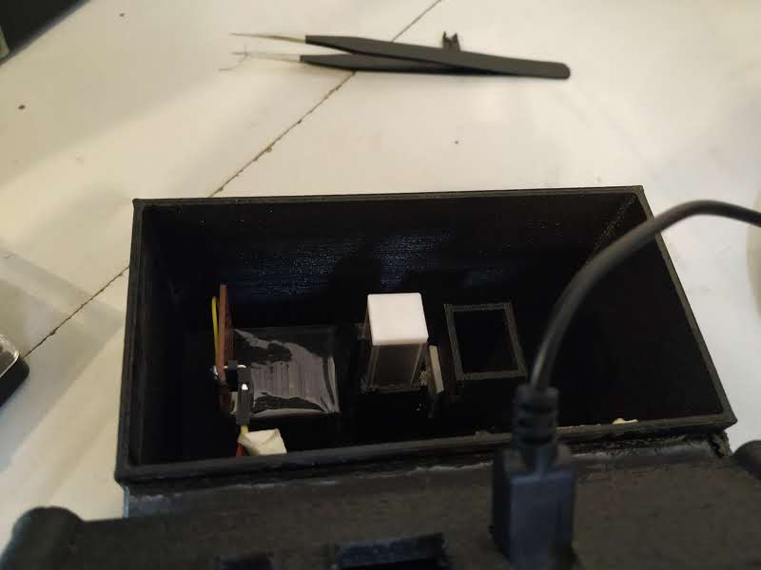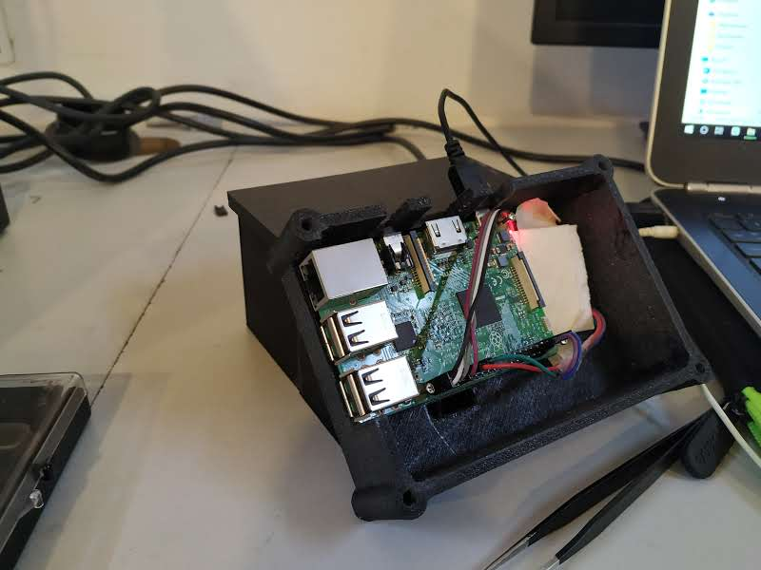

The list of experiments that have been performed on the designed prototype is given below:

* Analysis of Absorption of light v/s Concentration of Solution.
* Mapping wavelength to RGB.
* Uploading values to Google spreadsheet or excel sheet.
* Salt solution test for different concentration
* Sugar solution test for different concentration
* Plain water test
* Measurement of fat content in milk.

GUI :

